Equations

T(t)=f(U,D,A,Da​,N)⋅e−λt
Where:U = User trust score, D = Device trust score, A = Application trust score, Da​ = Data access trust score, N = Network context score, λ = Trust decay rate (aging factor), t = Time since last validation

Trust_Score=f(Data trust, Device Posture, Application infrastructure, User trust, network-trust Factor)+Inertia-Trust
$$TS=F\left(DT, DP,AT,UT,NT\right)+Residual Trust$$
Equation 2.1 Eventaual trust score as a function of Zero Trust pillars
Where TS is the eventual Trust score, DT is the data trust score, DP is the device posture trust score, AT is the application trust score, UT is the user trust score and NT is the network trust score. The residual trust is the initial trust value resulting from the last known transaction or a decayed trust value of the previous estimation iteration.

Access enforcements (e.g., MFA success, device compliance) are modeled as:
$$UserAcc=\left\{\begin{aligned}1 access \\ 0 No acces\end{aligned}\right.$$

Residual trust is decayed based on an aging factor based on empirical data for most enterprise devices as illustrated by equation 3
T(t)=T₀​⋅e−λt where T₀​ = Initial trust score, λ = Decay rate (per hour) and t = Time elapsed since last trust validation.

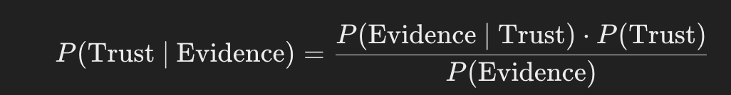

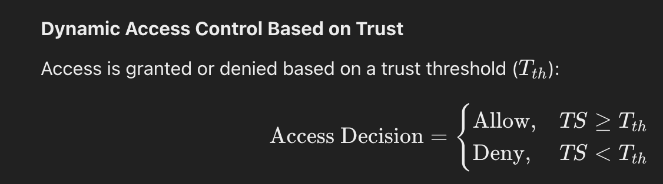





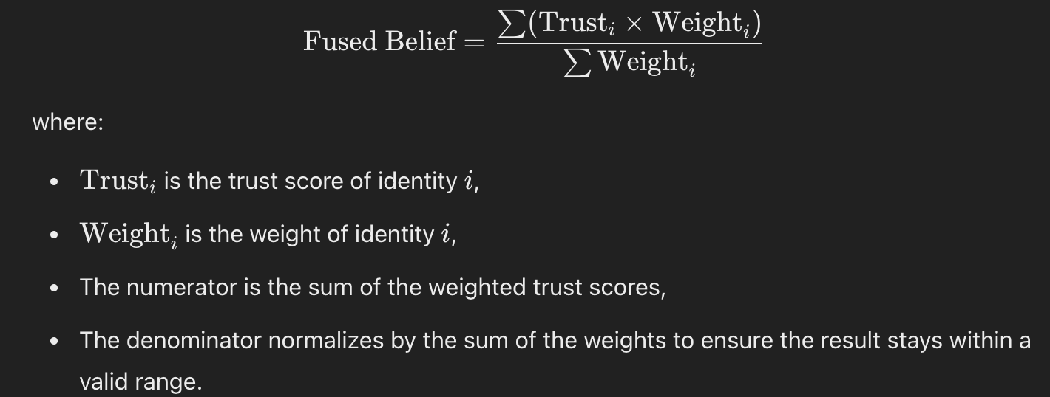

$$T_{ovr}=Wdat . Tdat+Wdev.Tdev+Wapp.Tapp+Wnet.Tnet+TrustRes$$
$$T_{ovr}={W_{dat}. T}_{dat}+{W_{dev}. T}_{dev} +{W_{app}. T}_{app}+{W_{net}. T}_{net}+{Trust}_{res}$$

Where:
Tovr= Overall trust Score and Tdat, Tdev​, Tapp​, Tnet​ are Trust scores for data, devices, applications, and networks (normalized between 0 and 1).
Wd, Wdev,Wapp, Wnet: are weights for the data device, applicatio and network conntexts. The sum of all weights shoild be 1

TrustRes: this is the residual score for a user based access transaction history

$$\left\{\begin{aligned}FullAccess,ifTov≥T_{h}igh \\ RetrictedAccess,ifT_{l}ow≤Tov<T_{h}igh \\ DenyaAccess,ifTov<T_{l}ower\end{aligned}\right.$$

